Watchman Recall Workshop – Module 4: Connecting Adverse Events to Recalls (Total Time ~ 60 Minutes minutes)
This worksheet guides you through Module 4 using ChatGPT to analyze structured MAUDE data, incorporate Field Safety Notice (FSN) context, and prepare for narrative clustering.
Note: To help you go through this module smoothly, your instructor will provide you with the source files and specific prompts. You can use the data files you created in earlier files, but you may find it challenging to complete this exercise in the allocated time. The goal here is to help you learn some of the advanced analytical techniques you can use with ChatGPT. It is strongly recommended that you repeat this exercise on your own using your outputs from previous modules.
Learning Objectives:
- Understand how structured MAUDE data supports recall signal detection.
- Compare structured data trends with manufacturer-reported FSN rates.
- Translate narrative insights into failure clusters (C1–C10).
Required Materials (Provided by your instructor):
- Watchman_Workshop_Training_Subset_1000_Clean_v2.xlsx,
- Recall_Master_Table_DQY_2016_2025_FINAL.xlsx
- Recall_Summary.pdf,
- Boston_Scientific_Urgent_Field_Safety_Notice_29July2025.pdf,
- Failure_Cluster_Taxonomy_Module4.pdf
- MAUDE_Summary_Tables.pdf

Part A — Structured Data Trend (ChatGPT First)

Start with a prompt like this before you upload the files:
“I am going to upload a few source files for our analysis in this chat. Wait for my next prompt before starting your analysis.”
Follow by uploading these files in the chat window:
• Watchman_Workshop_Training_Subset_1000_Clean_v2.xlsx
• Recall_Summary.pdf
• Boston_Scientific_Urgent_Field_Safety_Notice_29July2025.pdf
• Failure_Cluster_Taxonomy_Module4_v5.pdf

Step A1 — Confirm Dataset Columns
Objective: Ensure dataset integrity and identify key fields required for analysis.
Expected Output: A list of column mappings (OMI (Orca1 Mfg. Index, FDA Date, Patient/Device Problem, Narrative etc.).
Copy/paste into ChatGPT:
Confirm that the Excel file is loaded and map the key columns:
- OMI (Orca1 Mfg. Index)
- FDA Date Received
- MFG Date Received
- MAUDE Patient Problem
- MAUDE Device Problem
- Event Description/Manufacturer Narrative
Then report back the column names detected and any missing fields.

You should receive an output like this (Don’t worry if it is not identical):
Field | Detected Column Name | Status
OMI (Orca1 Mfg. Index) | OMI (Orca1 Mfg. Index) | ✅ Found
FDA Date Received | FDA Date Received | ✅ Found
MFG Date Received | MFG Date Received | ✅ Found
MAUDE Patient Problem | Maude Patient Problem | ✅ Found
Event Description / Manufacturer Narrative | Event Description/ Manufacturer Narrative | ✅ Found

Step A2 — Filter for Air Embolism (Structured Fields)
Objective: Isolate Air Embolism–related events using only the MAUDE Patient Problem field (code 1697) and analyze quarterly trends by standardized manufacturer groups defined by OMI (Orca1 Mfg. Index).
Copy/paste into ChatGPT:
From the loaded dataset, filter records where
• MAUDE Patient Problem contains “Air Embolism” (code 1697).
Using MFG Date Received, group results by calendar quarter and by Manufacturer Group (using the OMI field to classify Boston Scientific vs Peers).
Return a quarterly summary table showing event counts for each group, covering the entire dataset range.
Save the table as a CSV and give me a download link.

You should receive an output like this (Don’t worry if it is not identical):
Quarter | Boston Scientific | Peers
2022Q1 | 4 | 0
2022Q2 | 2 | 0
2022Q3 | 1 | 3
2022Q4 | 3 | 1
2023Q1 | 3 | 13
2023Q2 | 4 | 5
2023Q3 | 3 | 3
2023Q4 | 5 | 3
2024Q1 | 4 | 0
2024Q2 | 3 | 4
2024Q3 | 8 | 1
2024Q4 | 9 | 2
2025Q1 | 9 | 1
2025Q2 | 14 | 4
2025Q3 | 3 | 1

Step A3 — Plot the Structured Trend and Overlay Recall
Objective: Visualize Air Embolism events by month and overlay the Aug 2025 recall initiation marker.
Part 1: Copy/paste into ChatGPT:
Using the quarterly summary table you created in the previous step, create a scatter plot with dotted lines connecting the points for each manufacturer group.
Instructions:
• X-axis → Calendar Quarter (2022 Q1 → 2025 Q3)
• Y-axis → Count of Air Embolism reports
• Series 1 → Boston Scientific
• Series 2 → Peers (all other manufacturers)
• Each data point should be a filled circle; use a dotted line to connect points.
• Add axis labels, a legend, and title:
“Quarterly Air Embolism Reports — Boston Scientific vs Peers (MAUDE, MFG Date Received)”
• Export the figure as a PNG and provide a download link.

Expected Output: Line chart with two series (Boston Scientific, Peers) and a vertical recall line.
Here is an example – your output may not be identical
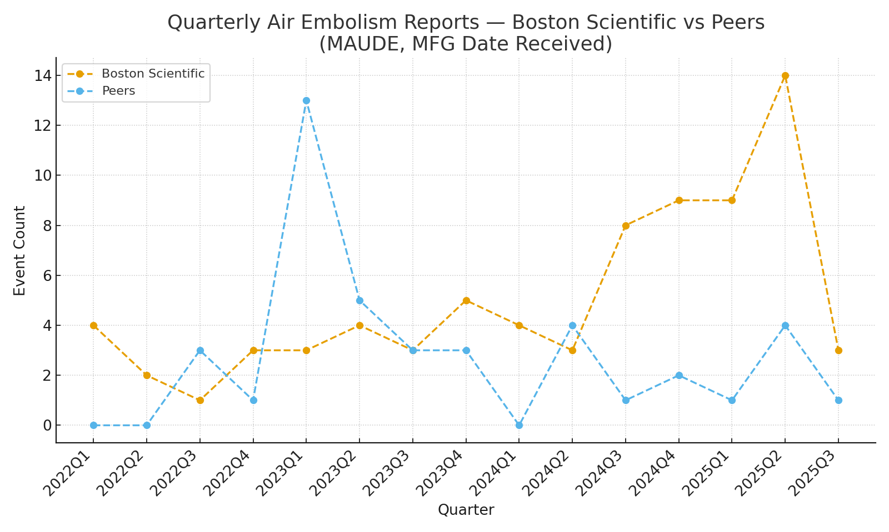
Part 2: Investigate the 2023 Q1 Peer Spike
Interpret why the Peer group shows a noticeable rise in Air Embolism–related MAUDE reports during Q1 2023, by connecting it to relevant FDA recalls.
Copy/paste into ChatGPT:
We observed a visible peak in Air Embolism–related events for the Peer group in 2023 Q1.
Using your loaded recalls dataset (Recall_Master_Table_DQY_2016_2025_FINAL.xlsx):
- Confirm the field names for: Recall Initiation Date, Product Description, Reason for Recall, FDA Determined Cause
- Filter rows where Recall Initiation Date is between 2022-10-01 and 2023-03-31.
- In those rows, search all three text fields for any of these terms (case-insensitive): "catheter", "sheath", "introducer", "access", "valve", "air", "embol".
- Return a table showing: Recall Event ID, Recalling Firm, Recall Initiation Date, Product Description, FDA Determined Cause
- Then add a short summary explaining which recall(s) may explain the Q1 2023 Peer spike seen in your MAUDE trend, and whether that signal came before or after the recall action.

You may receive an output like this:
Recall Event ID | Recalling Firm | Recall Initiation Date | Product Description | FDA Determined Cause
96545 | Teleflex | 2023-03 | Arrow® Introducer Sheath | Air ingress / valve issue
92502 | Abbott | 2023-06-12 | Amplatzer Amulet Access System | Procedural air management risk

And a narrative summary:
“The Q1 2023 peer-group increase likely reflects early field signals preceding the Teleflex (96545) and Abbott (92502) recalls. Formal recall actions followed roughly one quarter later.”
Part 3: Recall Events on the Structured Trend
Objective:
Connect structured MAUDE event trends with official FDA recall activity using the Effective Initiation Date field from the recalls dataset.
Copy/paste into ChatGPT:
- Begin with your scatter + dotted line chart from Step A3 (Part 1).
- Add vertical dashed lines at the Effective Initiation Date for each relevant recall:
Abbott #92502 (Class I) — June 12 2023, Abbott #96545 (Class II) — March 17 2025, Boston Scientific #97363 (Class I) — July 29 2025
- Place each label slightly above the trend lines to keep the chart readable.
- Keep the same legend for Boston Scientific and Peers; do not add recall lines to the legend.
- Title the chart: “Quarterly Air Embolism Reports — Boston Scientific vs Peers with Recall Markers (Effective Initiation Dates)”
- Export the figure as a PNG and provide a download link.

Expected output
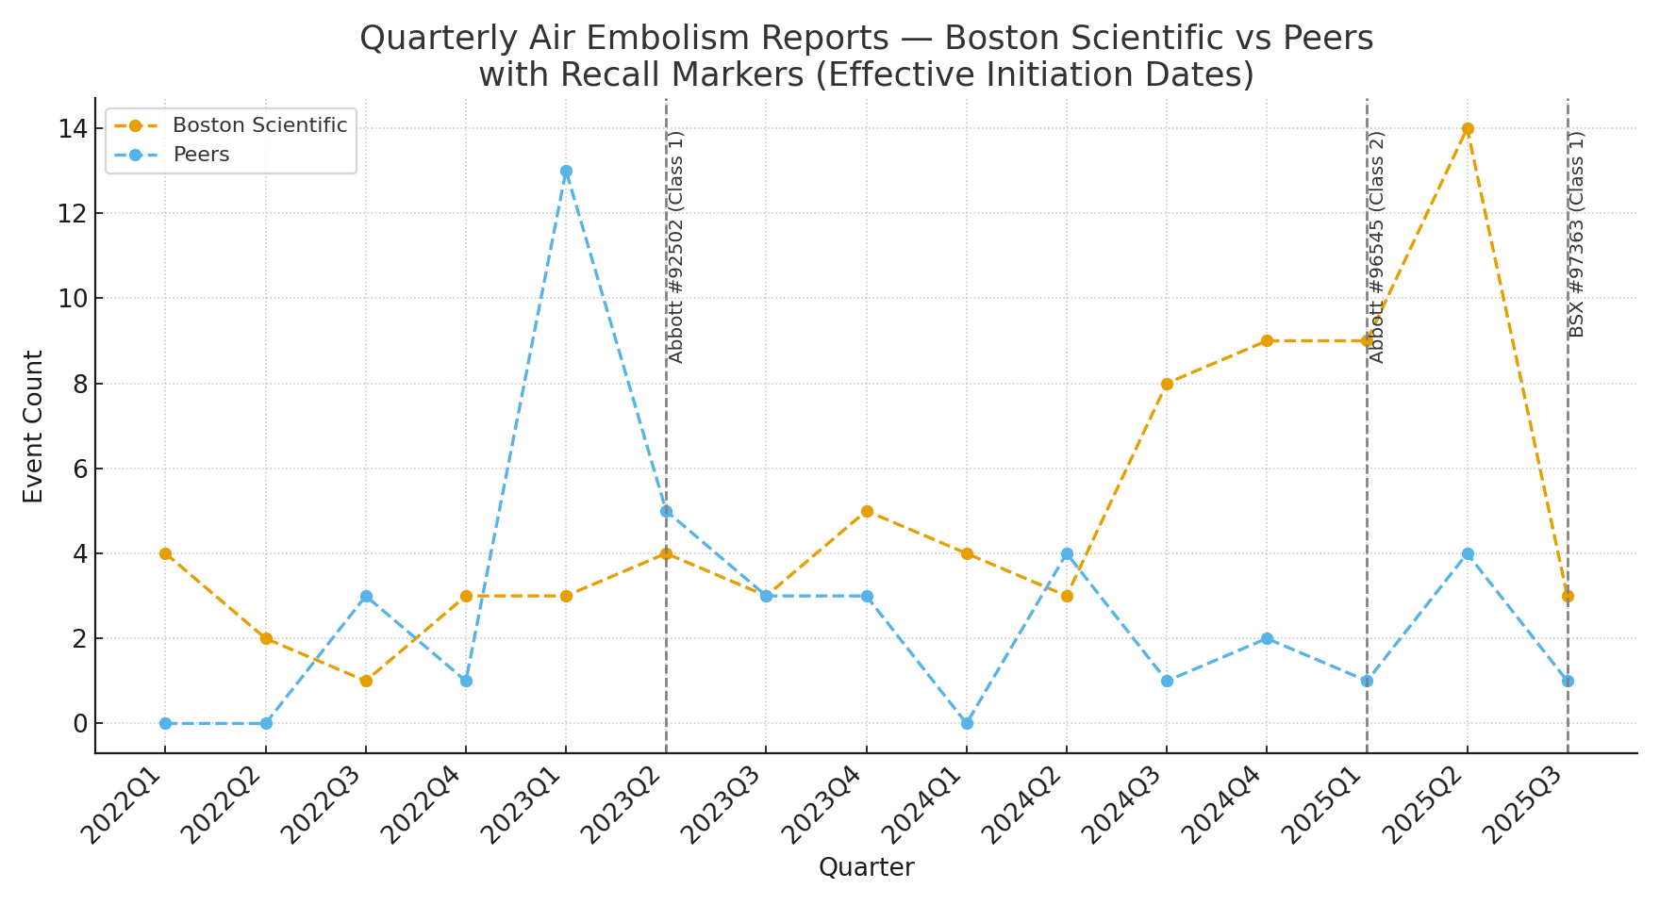

Step A4 — Visualize Device Problem Codes Associated with Air Embolism
Part 1
Objective: Identify the most frequent Device Problem codes co-occurring with Air Embolism (Patient Problem 1697), ensuring multi-coded entries are counted correctly.
Copy/paste into ChatGPT:
From your filtered dataset (Air Embolism Code 1697):
- Focus on the MAUDE Device Problem column.
- Some entries include multiple Device Problem codes, such as: Air/Gas in Device (4062), Material Integrity Problem (2978).
- Split each record into individual codes after every closing parenthesis — not just at commas — so each complete (term + code) pair is treated separately.(Hint: use a regular expression split like r'\)\s*,\s*'.)
- Count each unique code and term, sort by frequency, and calculate the % of total Air Embolism records.
- Display the Top 10 Device Problem Codes with columns:
• Rank • Device Problem Code and Term • Count • % of Air Embolism Records.

Expected Output: 4-column table (Don’t worry if you don’t get identical values)

MAUDE Device Problem | Count | % of Air Embolism Records | Rank
Adverse Event Without Identified Device or Use Problem (2993) | 68 | 58.6 | 1
Air/Gas in Device (4062) | 38 | 32.8 | 2
Material Integrity Problem (2978) | 5 | 4.3 | 3
Improper or Incorrect Procedure or Method (2017) | 2 | 1.7 | 4
Insufficient Information (3190) | 2 | 1.7 | 5
Leak/Splash (1354) | 2 | 1.7 | 6
Material Twisted/Bent (2981) | 1 | 0.9 | 7
Device-Device Incompatibility (2919) | 1 | 0.9 | 8
Defective Device (2588) | 1 | 0.9 | 9
Material Split, Cut or Torn (4008) | 1 | 0.9 | 10

Part 2
Objective: Visualize quarterly trends in MAUDE reports where Device Problem = Air/Gas in Device (4062), split by Boston Scientific vs Peers, and overlay recall events to interpret timing and signal behavior.

Copy/paste into ChatGPT:
From your filtered dataset (Air Embolism Code 1697):
- Split the MAUDE Device Problem column into individual codes as before (split after each ).
- Filter for records containing “Air/Gas in Device (4062)”.
- Use the OMI (Orca1 Mfg. Index) field to assign groups: If OMI = “Boston Scientific Corporation” → Boston Scientific, Otherwise → Peers
- Group the filtered data by calendar quarter (MFG Date Received) and Manufacturer Group.
- Create a scatter plot with dotted lines showing quarterly counts for both groups.
- Overlay vertical dashed lines at these Effective Initiation Dates: Abbott #92502 (Class I) — June 12 2023; Abbott #96545 (Class II) — March 17 2025, Boston Scientific #97363 (Class I) — July 29 2025
- Label each recall marker with firm name + class + event ID.
- Add axis labels and title: Title: “Quarterly Air/Gas in Device (4062) Reports — Boston Scientific vs Peers with Recall Markers (Effective Initiation Dates)”, X-axis: Calendar Quarter, Y-axis: Event Count
- Export the chart as a PNG and provide a download link.

Expected Output: Scatter Plot (Don’t worry if you don’t get identical values)

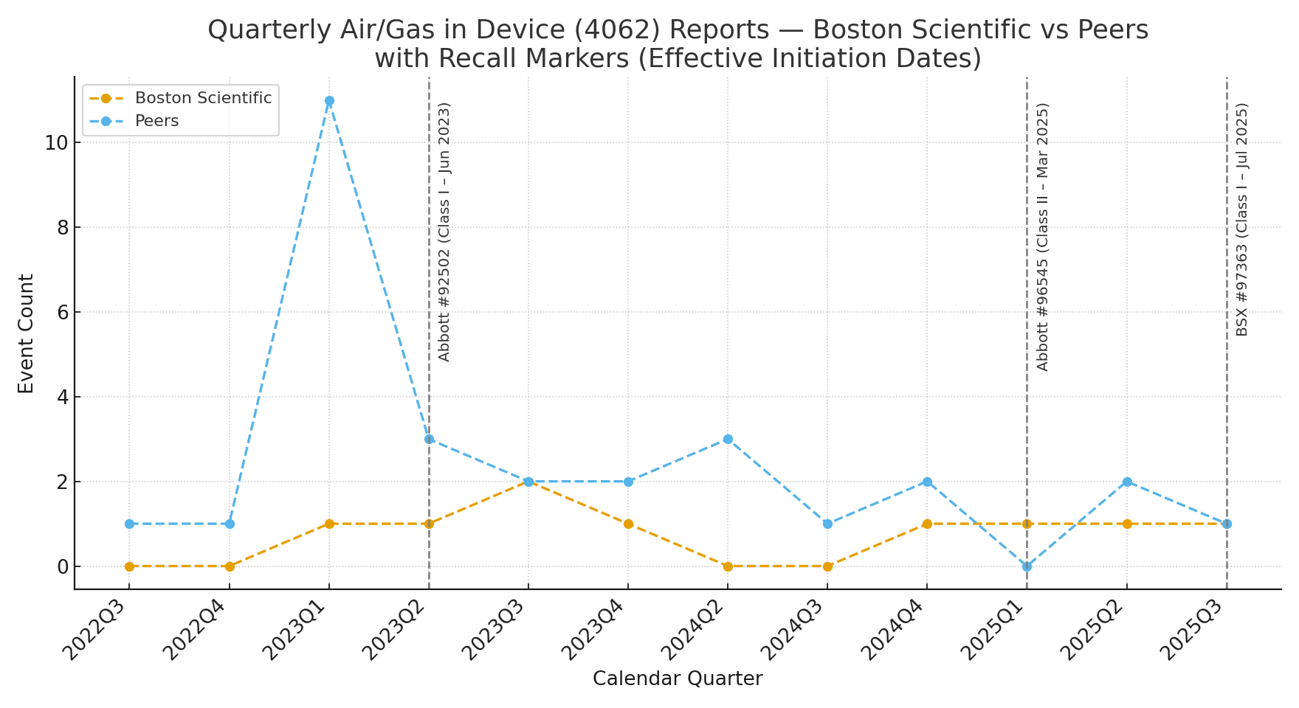

Step A5 — Reflection (Record Your Insights)
Use the space below to write 2–3 short insights about your observations, key challenges you face during analysis, and lessons learned about working effectively with ChatGPT.
1. ______________________________________________________________________________
2. ______________________________________________________________________________
3. ______________________________________________________________________________

Part B — Narrative Cluster Analysis
In Part B, you will apply the Failure Cluster Taxonomy to assign clusters (C1–C10) to narratives and trend them over time.
Learning Objectives
By the end of this exercise, you will be able to:
- Confirm that the Failure Cluster Taxonomy file is correctly loaded and understood.
- Review and interpret the clusters in a structured summary table.
- Apply cluster codes to MAUDE narrative text (Step B2).
- Identify 4–5 dominant clusters and plot them as time-series signals in the context of recalls, comparing Boston Scientific vs Abbott (Step B3–B4).
- Compare this narrative-based approach to the structured-data analysis completed in Section A, highlighting strengths and limitations (Step B5).
Step B1 — Load Taxonomy and List Clusters
You will first load the Failure_Cluster_Taxonomy_Module4.pdf file in ChatGPT.

Copy/paste into ChatGPT:
- Open the file Failure_Cluster_Taxonomy_Module4.pdf.
- Review the list of C-series clusters (C1 … C10) and their short definitions.
- Create a three-column table summarizing: Cluster ID (e.g., C1, C2, C3 …), Cluster Label (short descriptive title), Category Type (e.g., Device Failure, Manufacturer Action, User / Procedural Factor, Environmental Condition).
- Highlight or note which clusters seem most relevant to air embolism and access-system events (e.g., air ingress, valve seal, procedural exchange).
- Save or copy this table — you’ll use it to assign cluster codes to narratives in Step B2

Expected Output: 3-column table (Don’t worry if you don’t get an identical result)

Cluster ID | Cluster Label (Short Name) | Conceptual Domain
C1 | Valve Open / Vacuum Exchange | Procedural – Air Ingress
C2 | Deep Sedation / No Positive Pressure | Procedural – Sedation Context
C3 | Device Flushing Without Valve Closure | Procedural – Air Handling
C4 | Catheter Integrity / Fracture | Mechanical – Design Integrity
C5 | Difficult Removal / Advancement Resistance | Mechanical – Handling Resistance
C6 | Patient Hemodynamic Instability | Clinical Outcome
C7 | User Training or Technique | Human Factors
C8 | Manufacturer Investigation Language | Administrative / Investigation
C9 | Reporting of No Harm or Ambiguous Outcome | Reporting Bias
C10 | Environmental or Setup Factors | Contextual

Step B2 — Assign Clusters to Narratives
Objective: Apply the C-series Failure Cluster Taxonomy (C1–C10) to classify MAUDE event narratives and create a coded dataset that links each narrative to its manufacturing date and structured Device Problem code.
Expected Output: Table showing - Record #, Manufacturer, Assigned Clusters, Key Phrases Detected.
You will upload these two files (if not already done so)
- Watchman_Workshop_Training_Subset_1000_Clean_v2.xls
- Failure_Cluster_Taxonomy_Module4.pdf
Copy/paste into ChatGPT:
- Confirm that files have been loaded successfully
- Filter the dataset to include only records where MAUDE Patient Problem contains “Air Embolism” (code 1697).
- From this filtered subset, keep only the following columns: Report Number, OMI (Orca1 Mfg. Index), MFG Date Received, Maude Device Problem, Event Description / Manufacturer Narrative
- Using the C-series taxonomy (C1–C10), analyze each narrative and assign the most relevant primary cluster code based on context or keyword cues, If uncertain, assign C10 (Contextual / Insufficient Information).
- Return a table with the following columns:
Report Number | Orca1 Mfg. Index | MFG Date Received | Maude Device Problem |
Assigned Cluster Code | Cluster Label | Confidence (1–3) |Matched Terms | Narrative (Preview)
- Confidence: 3 = clear match; 2 = moderate; 1 = weak/uncertain.
- Save the coded output as Module4_B2_Cluster_Assignments_WITH_DeviceProblem.csv for use in Step B3.

Step B3 — Trend Narrative Clusters and Compare to Structured Signal
Objective: Plot quarterly trends for the most frequent narrative clusters (C1–C5) and compare Boston Scientific vs Peer-group patterns, overlaid with recall timelines. This illustrates whether unstructured-text patterns show early or different signals than structured MAUDE codes.
Note: You will upload Module4_B2_Cluster_Assignments_WITH_DeviceProblem.csv generated in Step B2, unless ChatGPT already has access to it in your current chat session.
Copy/paste into ChatGPT:
- Open the coded file Module4_B2_Cluster_Assignments_WITH_DeviceProblem.csv from Step B2.
- In ChatGPT, group the data by: Manufacturer Group: Boston Scientific Corporation → Boston Scientific, All others → Peers, Calendar Quarter: based on MFG Date Received (e.g., 2023Q1, 2025Q2).
- Count the number of MAUDE records per group and quarter, combining all clusters (C1–C10).
- Create a scatter + dotted-line plot with:
X-axis: Calendar Quarter, Y-axis: Event Count (all clusters combined), Orange line Boston Scientific, Blue line = Peers
- Add vertical dashed lines for recall Effective Initiation Dates: Abbott #92502 (Class I) — June 12 2023, Abbott #96545 (Class II) — March 17 2025, Boston Scientific #97363 (Class I) — July 29 2025
- Label the chart: “Quarterly Narrative Signals — All Clusters (C1–C10): Boston Scientific vs Peers with Recall Markers.”
- Export the chart as Module4_B3_AllClusters_Trend_With_Recalls.png, and compare it to the structured “Air/Gas in Device (4062)” chart from Section A.

Expected Output: Scatter Plot (Don’t worry if you don’t get identical values)

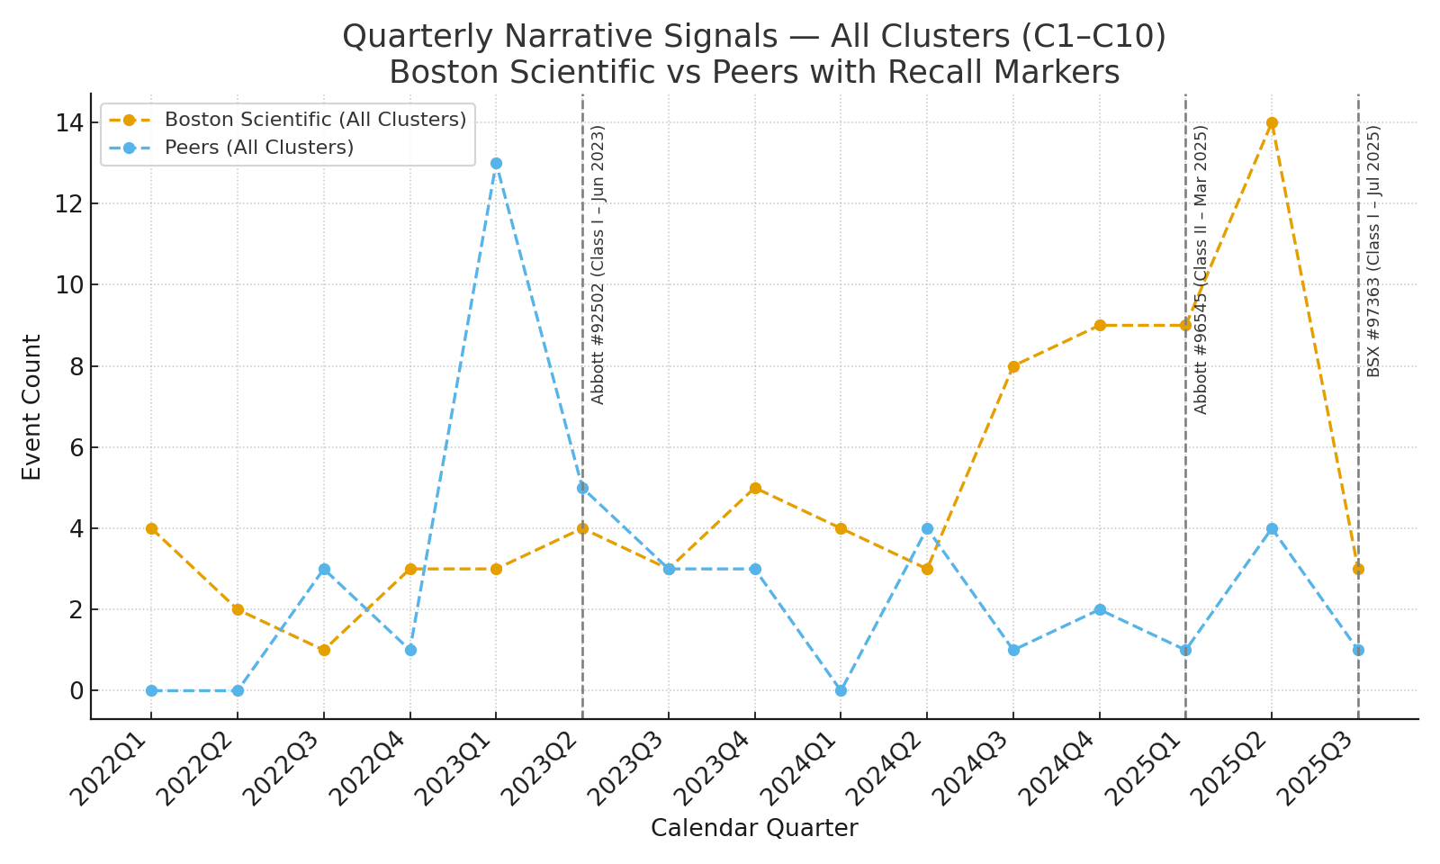

Step B4 — Short Interpretation
Copy/paste into ChatGPT:
In 3 bullets, explain:
1) What the structured-data trend suggests,
2) What the narrative cluster trend adds (earlier signal? mechanism?),
3) How these align with the recall initiation and FSN language.

